Instructions for abstract preparation for Prague 2024

J.L. First¹, P.L. Second² and J.C. Third²

¹Department of ……, University of Somewhere, City, Postcode, Country
²Department of …., University of Elsewhere, City, Postcode, Country
Presenting author email: j.first@somewhere.edu

The abstract should be typically one page long, maximum length is four pages. Use A4 page set-up and make all margins (top, bottom, left, right) 20 mm wide. Use 10 pt Calibri font (except for the title which should be in 12 pt bold and in sentence case). Centre the title, the authors’ names, the addresses, and keywords and contact email address.
Start each paragraph with an indent. Justify the body of the text both left and right. Use page numbers. Use Czech, Slovak or English to write your abstract, with an emphasis on describing what is new and why it should attract the attention of the audience.
Figures can be in colour or in black and white. Ensure that Figures and Tables have a caption and that they are numbered consecutively.
References should be made in the style (First, 2005), First and Second (2010) or as First et al (1996). Examples of references are shown below. Leave a blank line above the list of references, and also above the acknowledgements.

Abstract submission and review

The abstracts will be reviewed by the scientific committee. Abstracts which do not fulfil the standards will be rejected. Accepted abstracts will be published in the book of abstracts.
The abstract should be submitted in MS Word format. The deadline for abstract submission is 6th April 2024.

Table 1. Comparison between theoretical predictions and experimental measurements.
Month | Measured density (μg/m3) | Predicted density (μg/m3)
January | 0.4 | 121
June | 2.4 | 1.528×10⁴

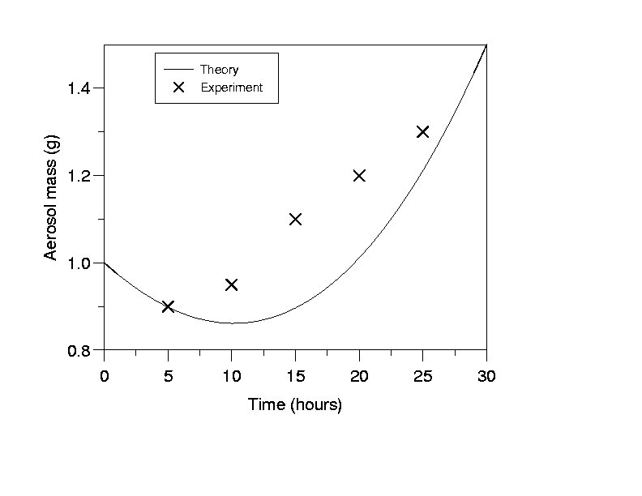

Figure 1. This is a comparison between theory and experimental data.

Acknowledgements: This work was supported by the Grant for Research HJ123.

References:
First, A., Second, B., Third, C. (1996) Proc. 3rd Int. Conf. on Research, World Scientific.
First, A. (2005) A book chapter on something interesting, University Press.
First A. and Second B. (2010) Int. J. Res. 210, 110-115.

